**MOBILE APPLICATIONS LAB 3**

**SPLASH SCREEN**

**NAME: LENA GEO**

**REGISTER NUMBER: 2241139**

**CLASS: 5 BCA-‘B’**

A splash screen in mobile app development is an introductory screen that appears when an app is launched, displaying a logo, app name, or other branding elements. It provides a visually appealing transition while the app is loading and initializing, enhancing the user experience by reducing the perception of wait time.

**CODE:**

**MainActivity.kt**

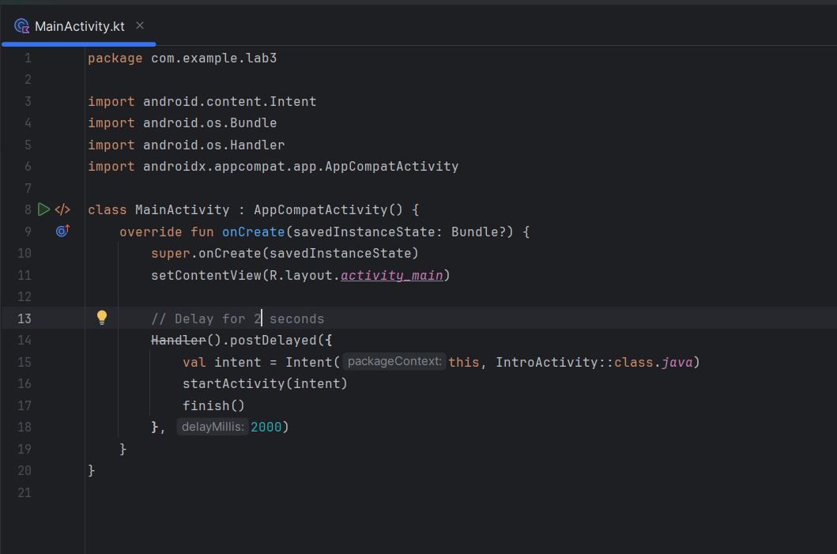

**IntroActivity.kt**

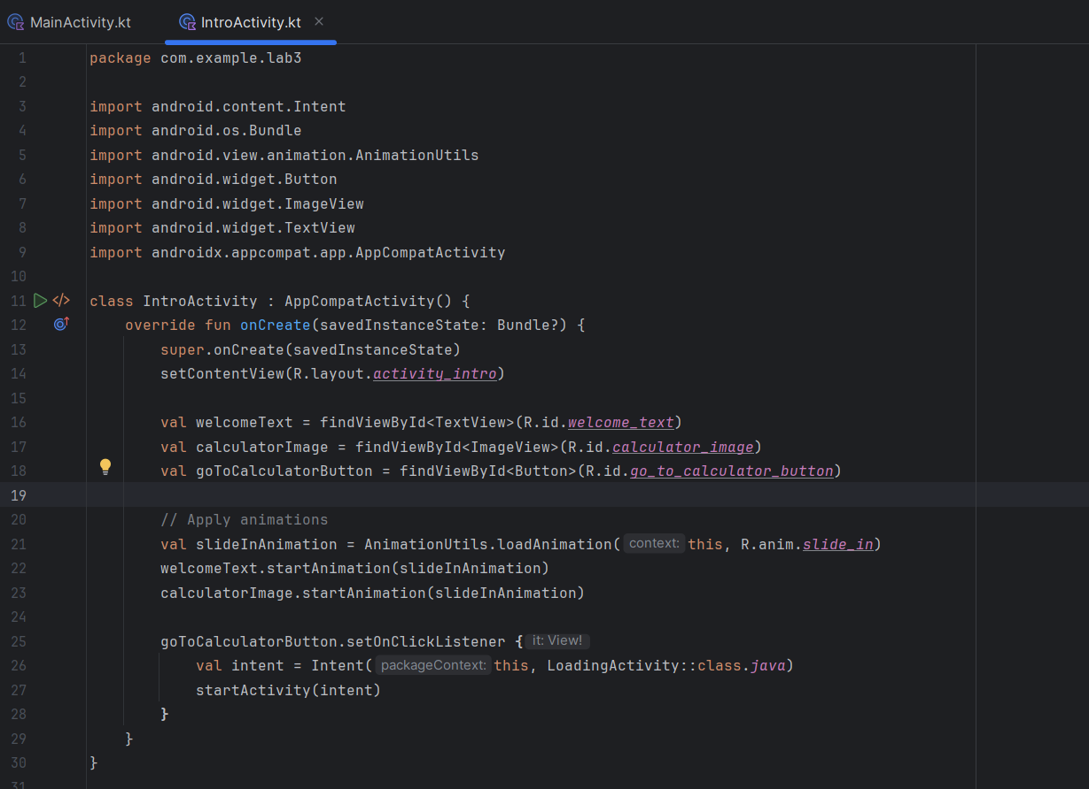

**LoadingActivity.kt**

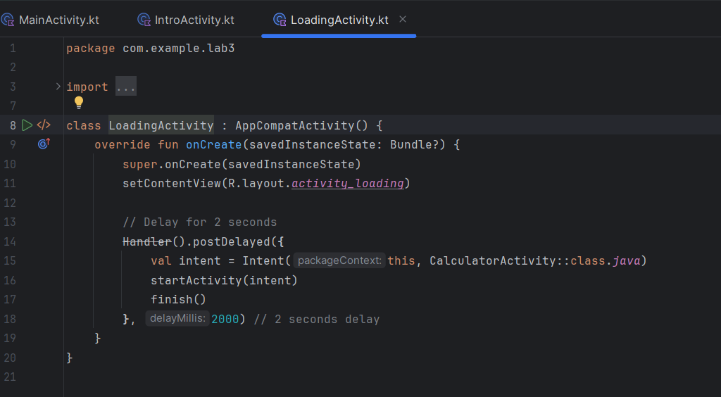

**CalculatorActivity.kt**

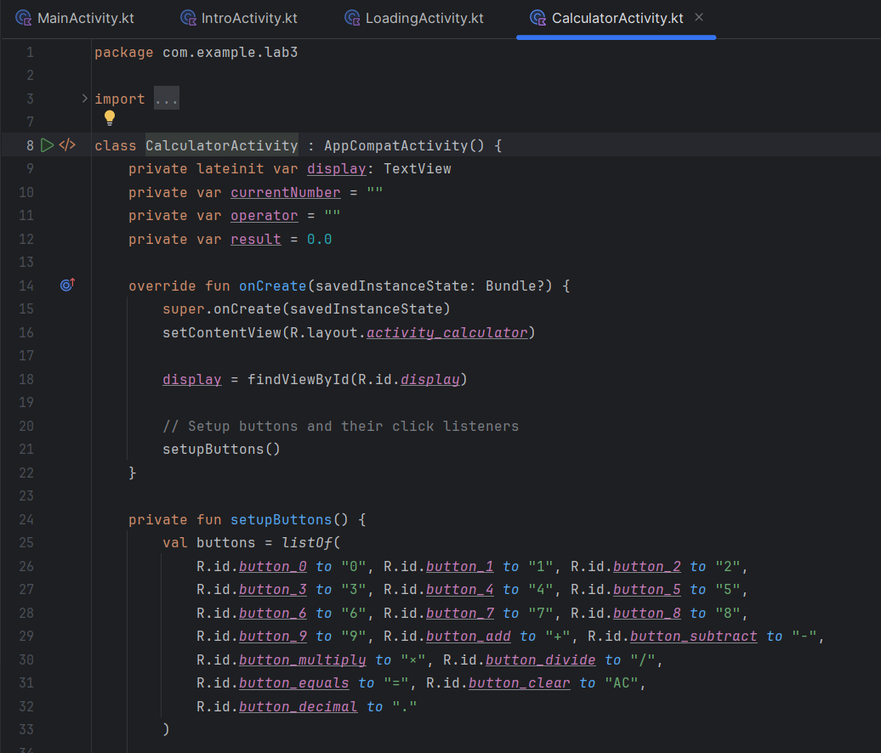

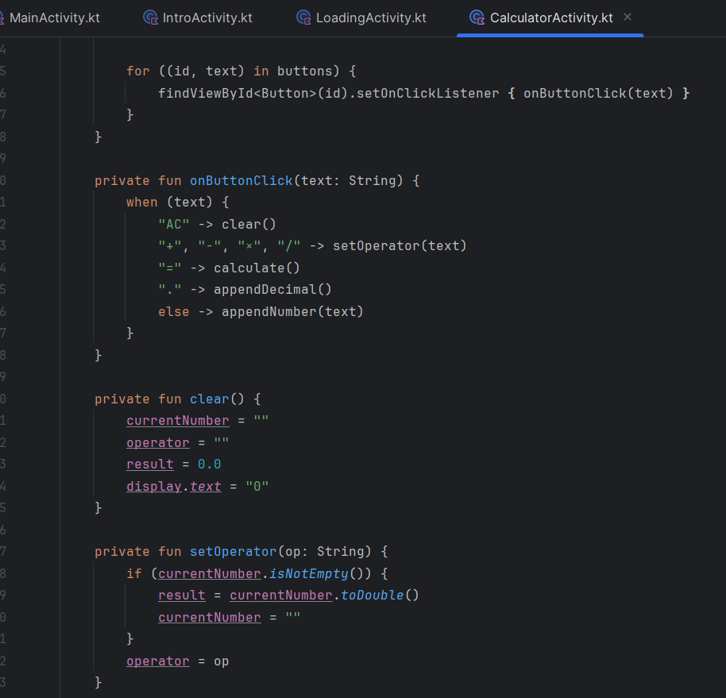

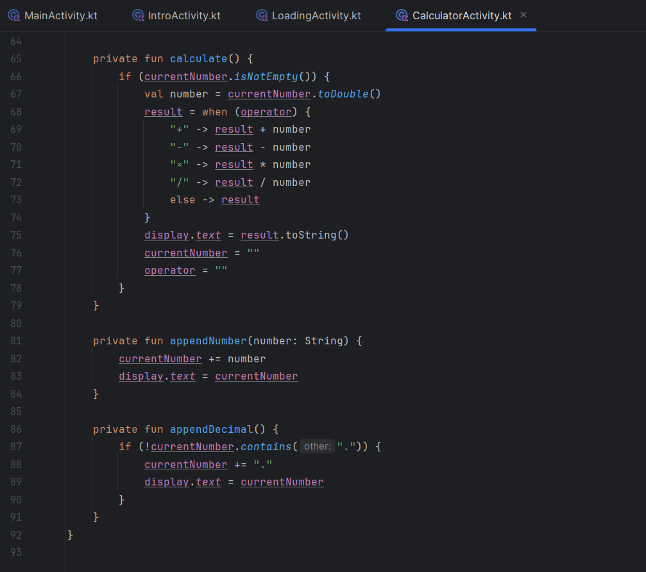

**OUTPUT:**

First splash screen on app opening:



2nd Activity: (transition applied for complexity)

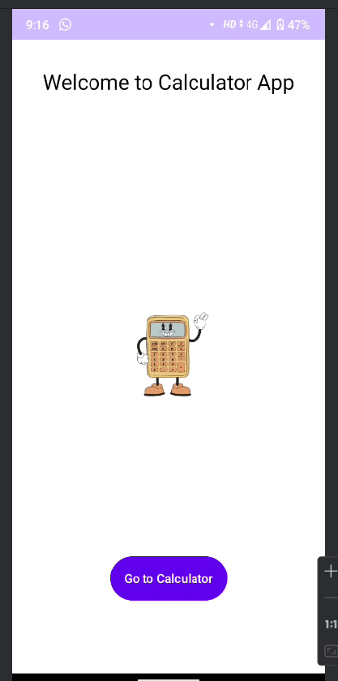

2nd Splash Screen( upon button click)

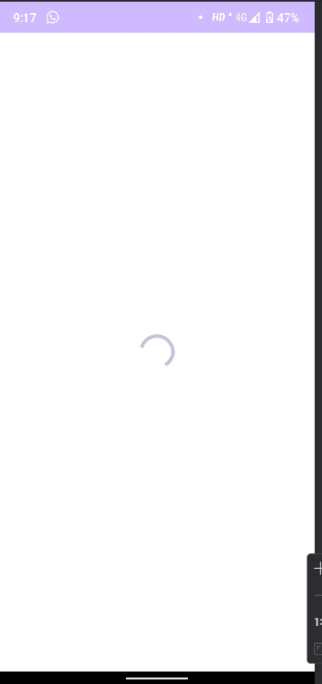

4th Activity with calculator functionalities:

